Zonal Employee management system
michael surgeon
26/1/19

Overview

Project brief and overview
Zonal has proposed a system in which it will be easier to manage their employees’ details and a system that centralizes the whole management system. The system should have different options to access the data. The program must be internet driven. It should create a report of each employee at the end of each month through the details of the database that will be updated through the program. The program should be made efficient.

Requirements
- Admin privileges – the admin will be the chairman of zonal, they will have access to the passwords and usernames of everyone in zonal. They will be able to add and remove anyone from the program/database.
- Login - The user will get access to the system only after they will enter the password and ID from the admin.
- Register – the user needs to provide the information to get registered into the system.
- Details – This module will provide the details of each employee who is working in zonal.
- Help – This will provide instructions about different options provided in the system.

Stages of development
- Stage 1 – This stage will involve wireframing, pseudocode and user experience planning this will help me quickly update different changes I would like to make for either efficiency or user experience.
- Stage 2 – Setting up the C# project and getting some main features working such as the home page linking with all the other pages of the program such as details and report making.
- Stage 3 – Creating the database will be the third stage this will probably take the longest as I have little experience in linking a database to a C# project although I think this will be manageable I don’t know whether to link an online database so its always up to date or a manually updated visual studio database as its to be internet based or I could use both and have a backup database incase of internet problems for efficiency.
- Stage 4 – Working prototypes should be done by this stage, so hopefully by the start of April, there will be a working project that is rough looking as ill have the rest of the months to touch up on user interfaces and code management for better user experience.
- Stage 5 – The final week should only be polishing up certain things such as colors etc.

Program Planning
I will create a separate document that shows the classes I may or may not need so I have them ill set up different layouts to see what could work best through my pseudocode. Setting up my program will include 5 forms and 4 classes.

Database Planning
I will try using the internet to learn more about linking databases and ill try and see which is more efficient and how to save the data through DataGridViews in visual studio. I will make to list all things required this includes:
- Job Title
- Role (Manager, Supervisor, Employee Etc.)
- Name
- Address
- Age
- Salary
- Department (work location)
- Email
- Working project
The database will include all these fields and should be populated unless states otherwise I will create a document with all the tables and fields filled in with the different datatypes so I can just put it in the database in the program when ready.

Wireframing TBC
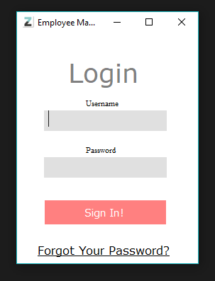
This is the login theme I’m going to go for as its simple and easy to use and provides an admin login as well as a registration.
A lot of my wireframing is on paper so will be added in due time. (Wont be completed as a new UI is in place)

Final User Interface
For the final interface design, I have went for a simple and easy to use design as shown from the pictures in the programming log this design is consistent throughout to make it easy to use for not only admins but employees as well. This will allows the employees to search for any information they need such as other employees emails etc.

Programming Log
So in the first 3 days I have managed to get an admin login which looks like this : 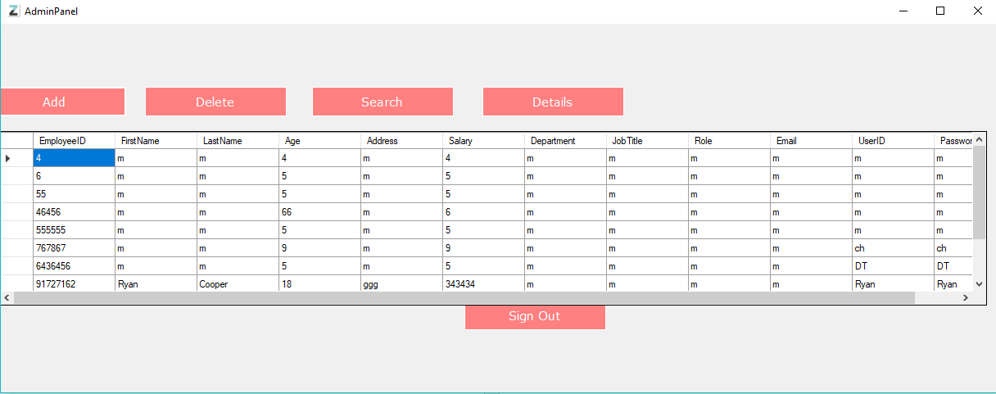
Obviously this isn’t done this is just me testing to make sure I can get an admin log in working and I have, I have a fully functional registration system working now I am at some point going to change the userid into just the employee id so there is no login duplications there is also an employee panel so if you sign in as an employee you are prompt with a different grid view which removes access to add, delete and doesn’t show you the user id and passwords of accounts.
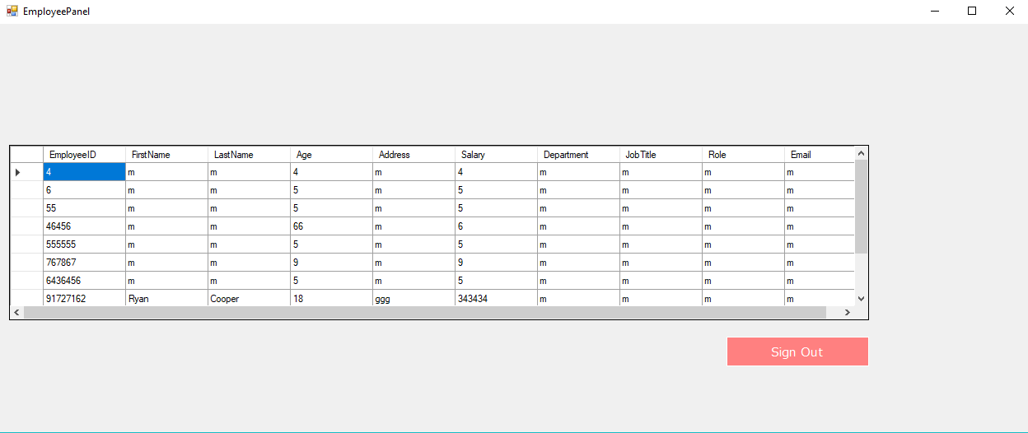
As you can see this is the very bare bones employee panel and it will have a lot more panels on the page other than just the DataGridView
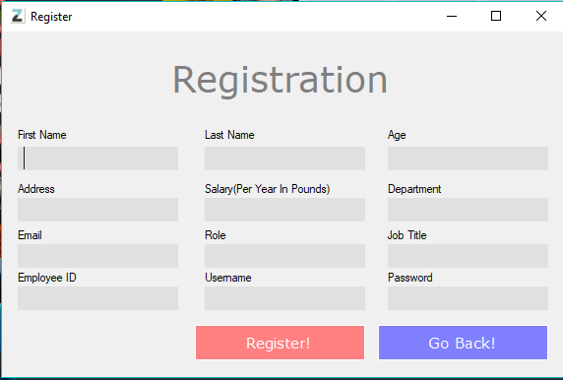
This is the registration page that works fully once registered your name, age etc. are logged into the database so you can log on etc. there will be an updated version of this such as a drop down for departments and username will be removed for more efficient data use, the username will be your employee ID which will have a different type of validation it will be 8 numbers long and given to you when signing with the company all you have to do is get an admin to add you to the database.
Things that are needing changed –
- Username should be removed for employeeID so there is no Login credentials that are duplicated. (Not needed anymore after validation)
- Admin login shouldn’t be set as its bad for security reasons
- I need to update the login feature for passwords as they are only lightly encrypted
- Fix a bug that sometimes the sign in button doesn’t work (requires a program restart)
- Optimization of code as there is unnecessary sql connections which takes up more processing power.

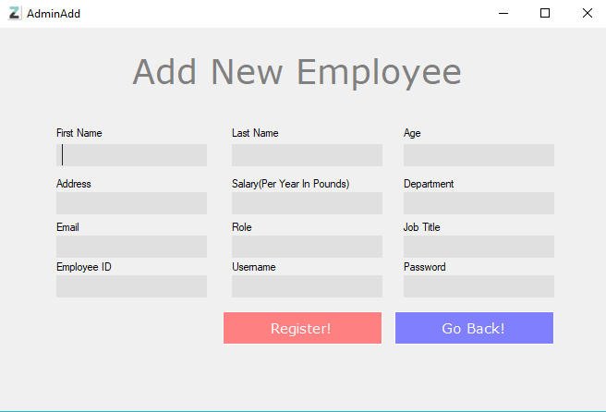
Tonight I added an admin add panel this is incase a new employee forgets to sign up this means its easy to access his/her computer access password etc.
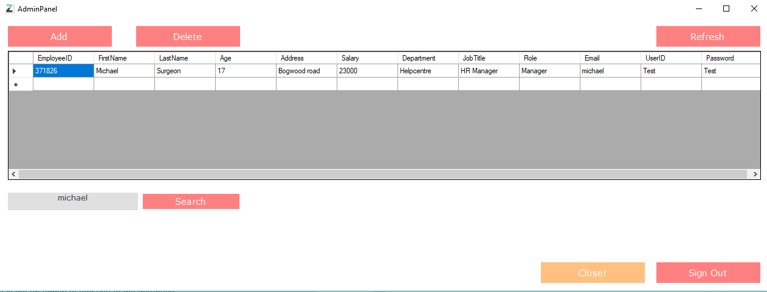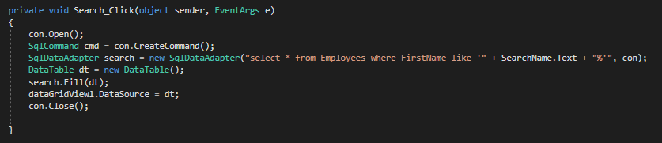
I added a search function so you can search the datagridview in order to find the person you are looking for this actually proved a lot harder as I first tried to search only using the grid view but later found that this would save if edited as there wasn’t an open connection to the database therefore I had to open the sql connection and search through the table in the long run this is a more efficient way to search through the database for me I believe it will also allow me to change it up a little for the employee home panel if need be.
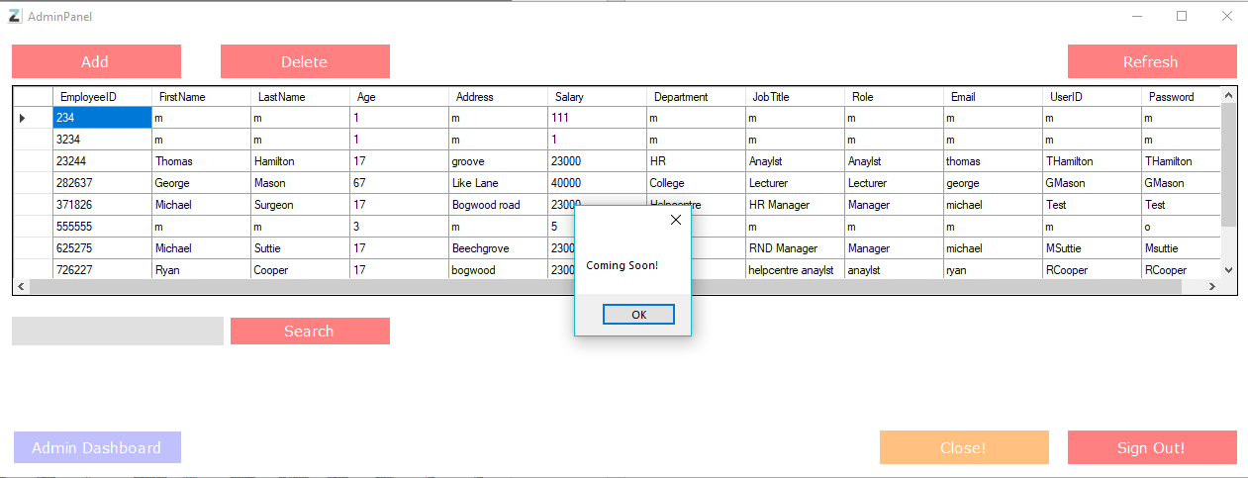
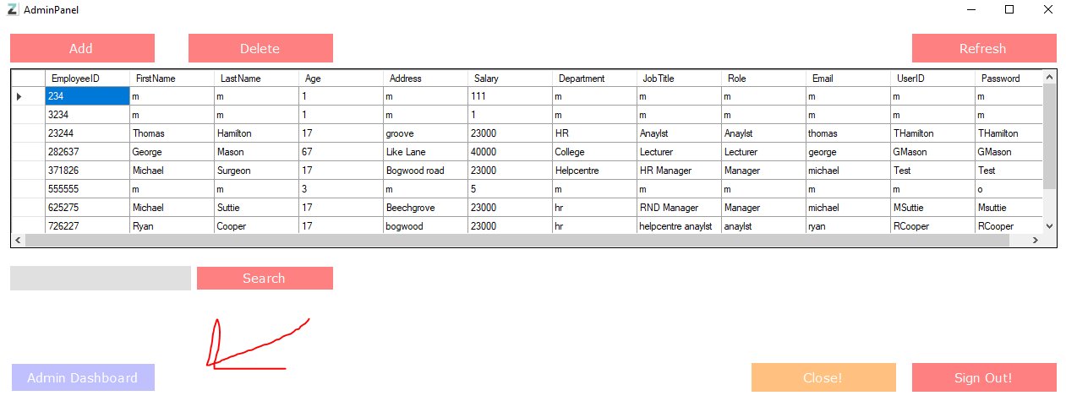
So I have Added and admin dashboard button this will allow admins to have limited ability when it comes to employee leave and rotates and will have an email system so they can send out emails to staff members.
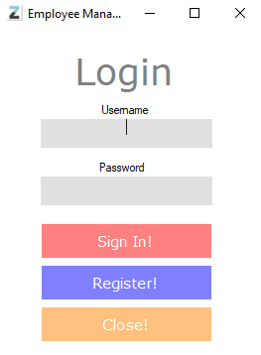
So this is the new and improved login screen it’s a tad different to my previous login wireframe concept as it now has a close and proper register functions, I added the close button so it kills the application as windows has a tendency for this program to run in the background even after a (Application.Exit()) so I took the courtesy to add this function it is now on most panels. I made sure to have the tab indexes in order the only thing I’m trying to solve is the textbox text lineup as you can see for the image the line isn’t in the center of the textbox due to resizing, I’m not sure how to fix this as of yet.

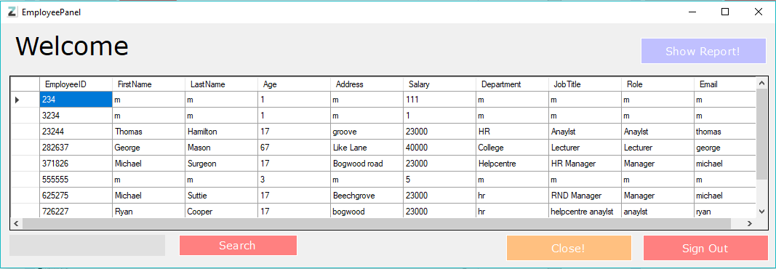
This is the overhauled EmployeePanel this new look I’m loving! Its simplistic easy to use and has no issues. The search feature works as shown below! And there is more features to come to this panel as well firstly in the top left I want it to say Welcome, “Username” so it provides a bit of character and makes it seem individual to you, secondly there is a new button which reads “Show Report!” this will show you your monthly report and will update depending on the information the admin has updated on the admin table this is still a feature to be added but will hopefully be in the finished development.
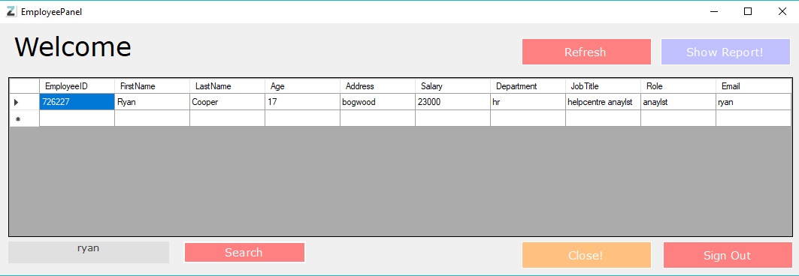
So About an hour later I came across a bug where if I type something in the search function and press enter then press search nothing appears and there was no way to get back the contents of the database so as a temp fix I have added a refresh button which reloads all the content back into the datagridview in order to see the data once again. You Can see the bug in the image to the side.
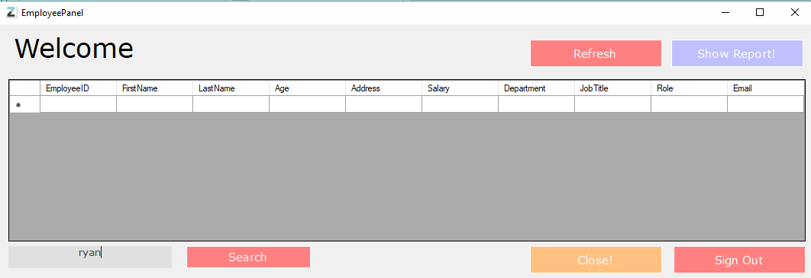
As you can see there is no populated fields in the database but after pressing the refresh button everything goes back to normal, I will have to find a proper fix soon.
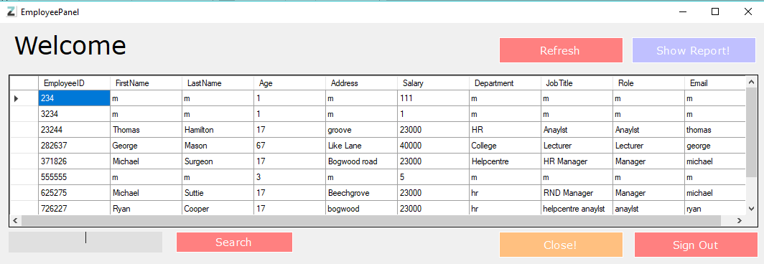
This is what it looks like after the refresh button has been pressed.
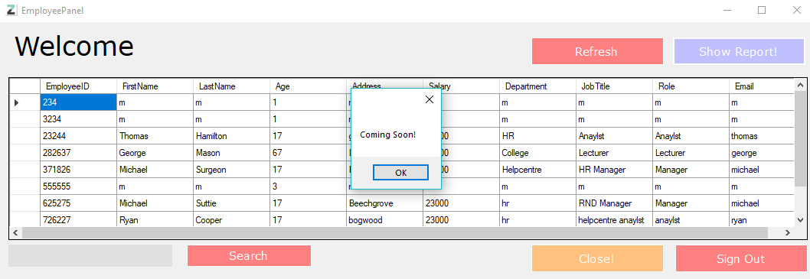
As you can see this is the show report function that will be added in times soon to come this will hopefully allow employees to track what kind of things they have achieved for that months.
Things to achieve from this point on:
- Show report feature working
- Admin dashboard prototype working
- The database final design to be completed
- Password Encryption
- Auto Database update system
- Drop Down Menus in registrations for certain fields(Departments, role etc)
- Remove salary and address from employee panel and include different search functions including search by id

I have now added a non-necessary feature although its nice to have once pressing the refresh button it will clear the search box by using a simple pre-defined function called SearchName.Clear(); this is just the name of the textbox and the clear function it works well.
So as of now there is an admin dashboard as shown below
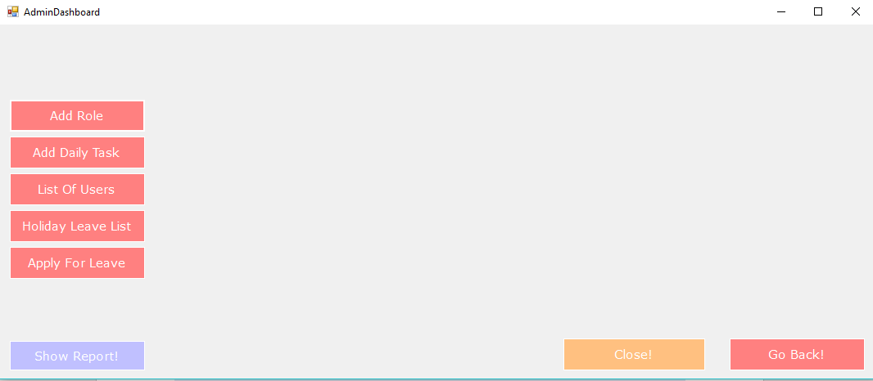
The add role function and the list of users are working, I need to make a new database for roles this will allow me to create that drop down feature that I want to add the list of users basically just allows you to see the whole database in order to see what’s on hopefully it will show active users.
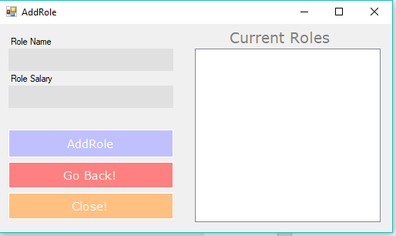
This is the add role feature this will allow you to add center roles such as manager etc so I can later add it onto the registration page as a drop down so its easier to select your role etc.
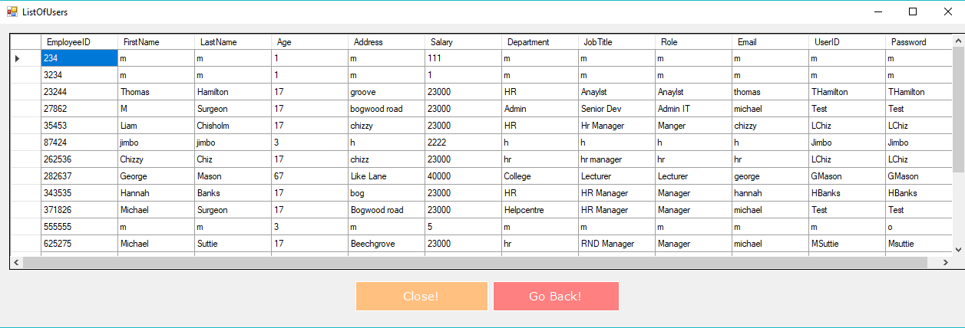
This is the listofusers panel this is basically just showing the database so you don’t have to go back to the adminpanel to see everything.
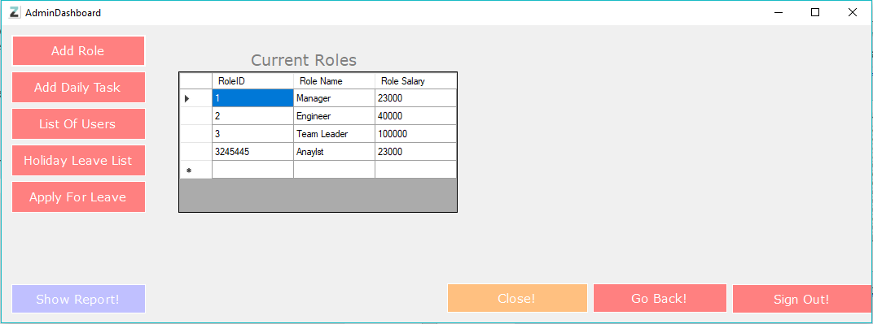
So today I have added a role system this isn’t the most exciting thing I fixed the auto update for the DataGridViews this was plainly me being a bit stupid as I was only updating them through the refresh buttons instead of doing that I just used the same code but instead of putting it in the refresh button I just done it through the form load function I should have done this at the start but at least its done now, the refresh button is still needed for one more bug which is the enter bug that has previously been stated.
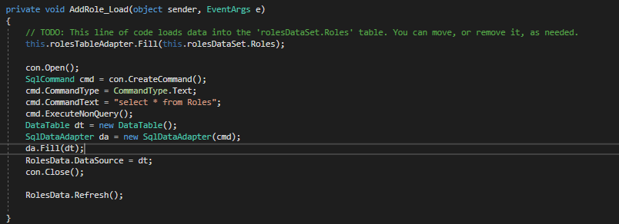
This is the code in the form load basically it fills the dataset first them opens the connection to the data source creates a command and then selects all columns in the table and executes a non-query as there is none to execute, then creates a new data table and fills it and finally refreshes the datagridview.
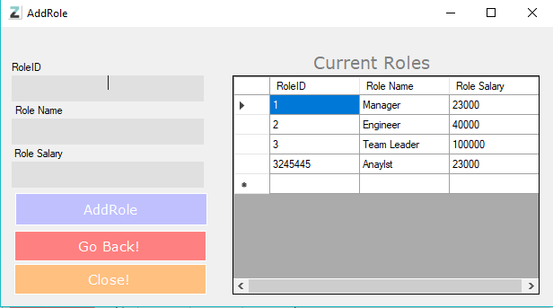
This is the AddRole panel on the admin dashboard and it is fully functional and has its own table in the database now this is going to be key for my drop-down system hopefully.

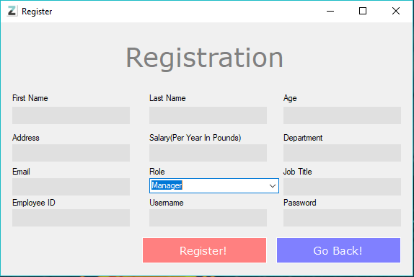
The new drop-down feature is fully functioning and now allows people who are registering to pick their role.

So after completing this system I added another drop down to the department and stored it into a database to use the drop down menu, but I have also stumbled across an issue the issue being that a employee can basically just select their own salary obviously this is very flawed so if you see the picture on the next page.
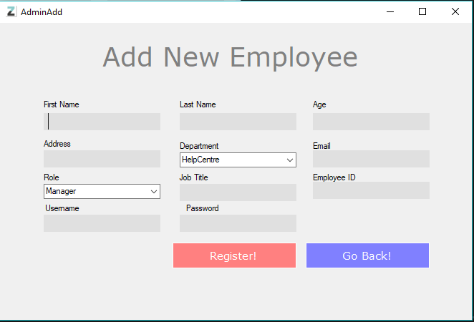
As you can see the salary text box has been removed and it basically sets your salary based on your role now yes, I know this is a bit broken as people in the same role can have a higher or lower salary based on age etc. So eventually I will move this system to a database crud system for salary as it makes more sense but for now I have done a really simple and inefficient fix but this will not make final development.
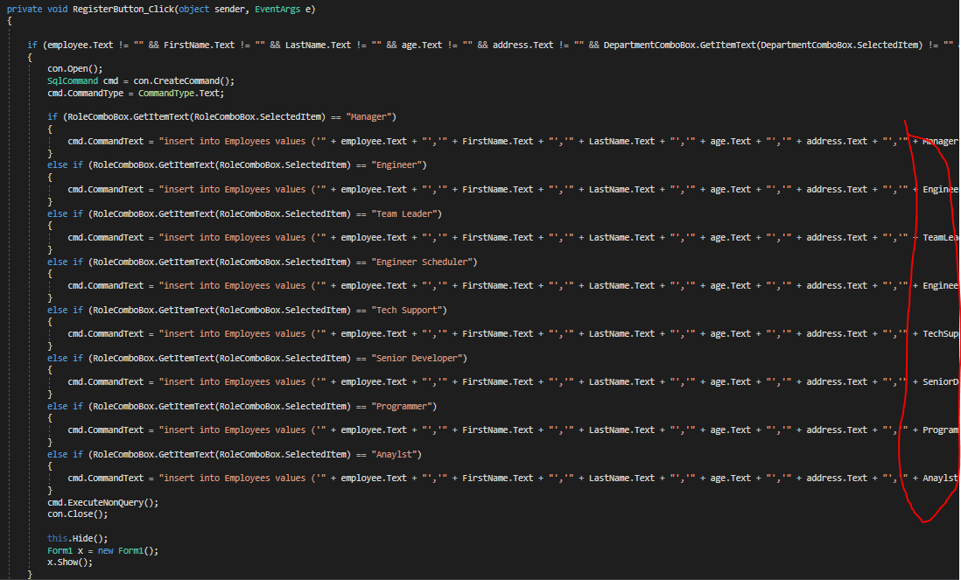
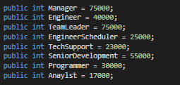
NOW yes I know what you are thinking that’s a really inefficient way of doing the salary but hear me out I was just testing this function to see if it will be possible to do it through a database the way it works is it takes the data that is in the role drop down box and sets the salary based on the selected role so each role has a set salary through the variables that are set now obviously this has to be changed and it will be but for now this will do while I work on different features that are more important right now. One being the delete function on the admin panel, basically the function works but if the button is pressed without anything being selected it will spit out this error.
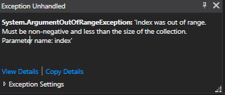
Now this is mainly because either you have a row in the datagridview selected thus meaning the index is either 0 or -1 but if nothing is selected the value becomes 1 causing the system to crash as the index value is 1 when 1 doesn’t exactly exist. I’m still trying to work on this system and should hopefully have it fixed soon. Basically, in short terms its trying to access part of the index array which isn’t in range.
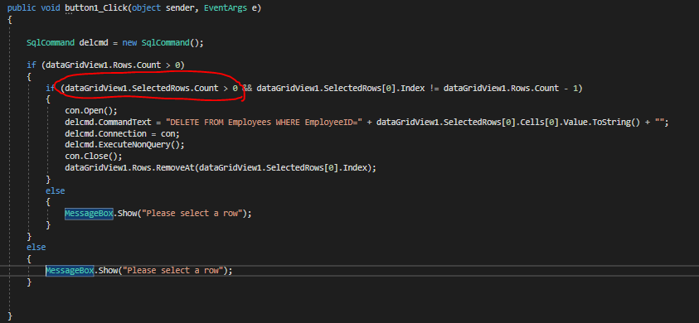
So this is how I fixed the exception error Instead of searching rows.count as it doesn’t guarantee the contents of selectedrows.count so basically I just checked the contents of selected rows this fixed the issue.
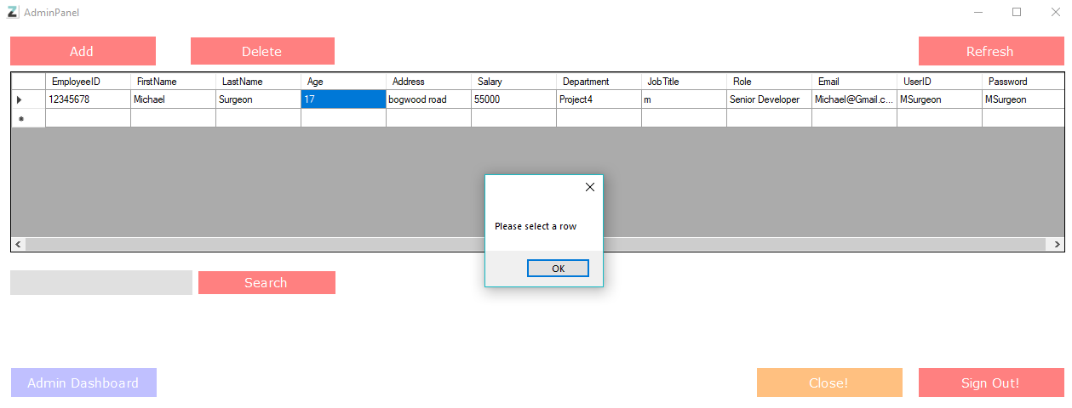
As you can see this now fully works and hopefully will stay that way.
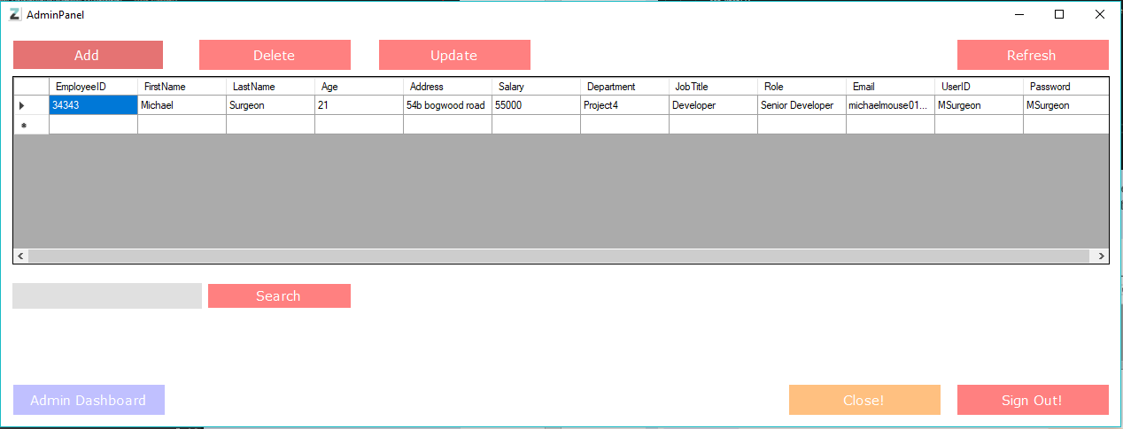
I have now added an update button besides the delete button I have had a few issues with this so far, but I will hopefully figure it out soon!
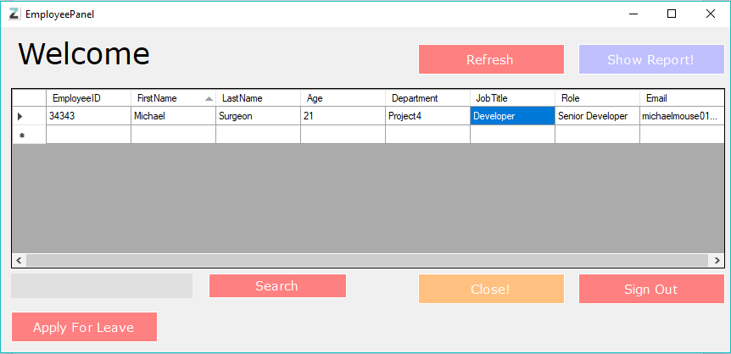Added a nice feature where the employees can’t even write into the datagridview as this could cause a crash the line of code I used was - this.dataGridView1.ReadOnly = true; this basically set the grid to read only so they can just look through the record.

So now comes the fun features that I have started implementing the first one being tasks admins can now set tasks as you can see and they are displayed not only on the admin dashboard but also the EmployeePanel that has been revamped for this feature!
As you can see on the next page its starting to come together tomorrow is going to be a day where I start going through my code and optimizing it! As it’s a must.

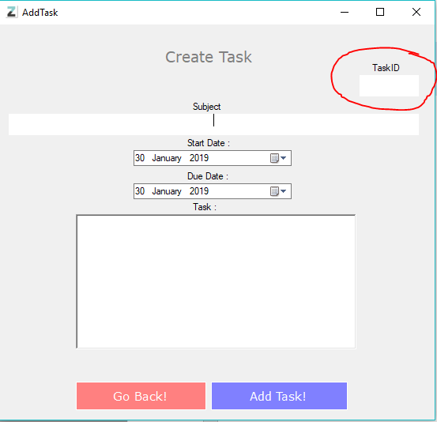
As you can see this is the add task panel located on the admin dashboard the only thing I want to change about this system is the task ID I just want this to be generated randomly as it’s a bit of a pain typing it out.
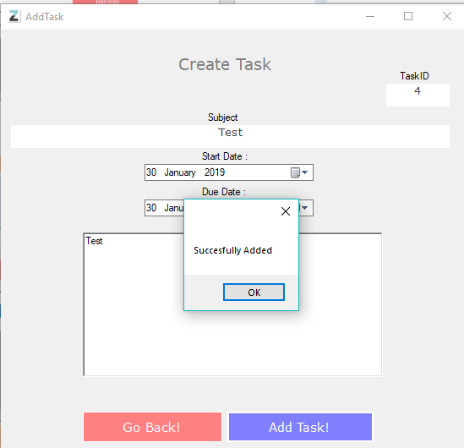
As you can see you successfully ad a task and it goes straight to the admin and employee dashboards!
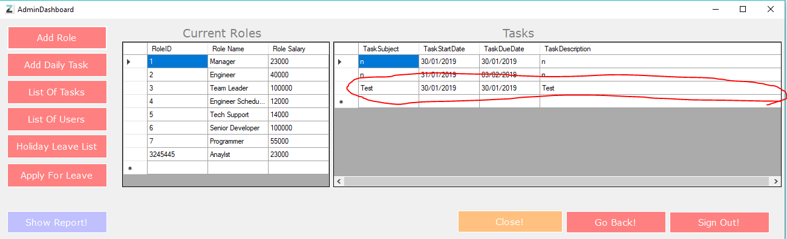
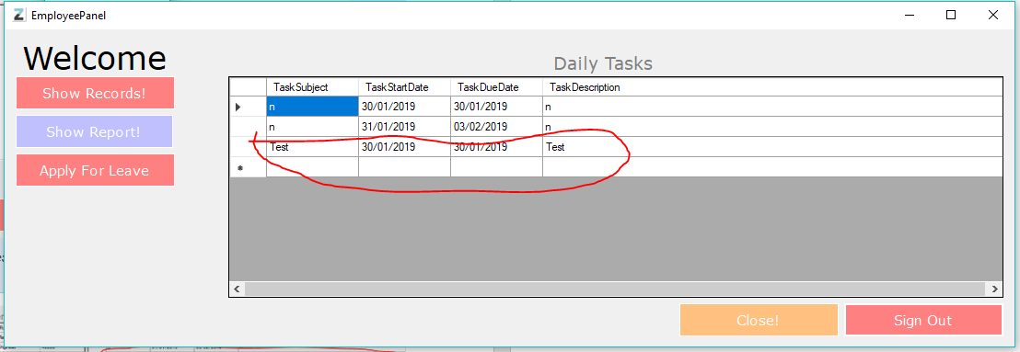
As you can see the task has been added to both dashboards and as you can see the employee panel has had a bit of change as having the database records and tasks on one page made it seem clutters. Anyway back to the tasks so I want to implement a feature where if an employee creates a task added by the admin the will be able to select that task and press completed and this will then remove it and delete it from the database as only admins have that privilege right now as shown below on the list of tasks panel.
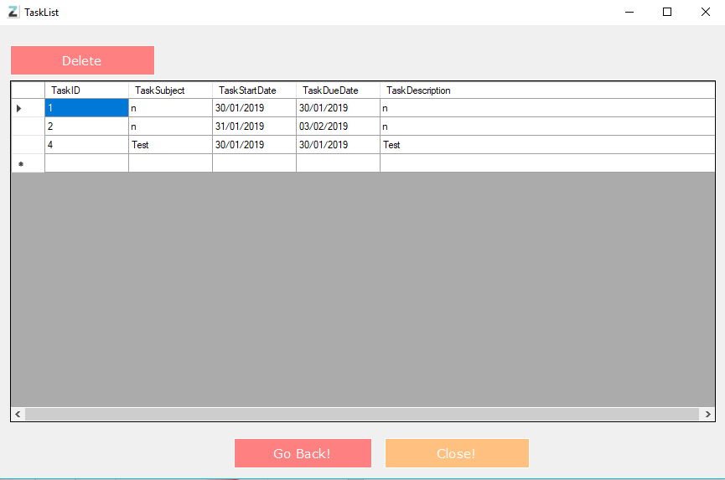
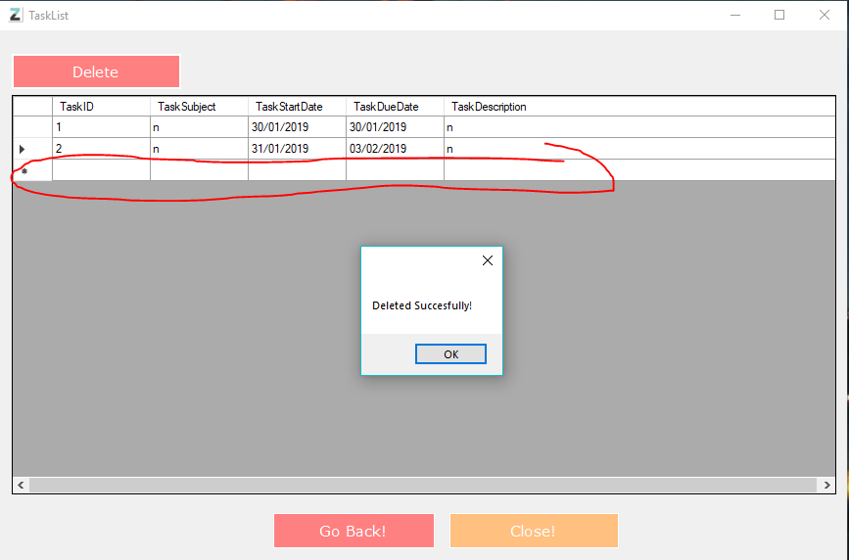
As you can see it is then successfully deleted from the system, I’m really happy with the feature as I don’t have much experience using sql for tasks but It seems to work fine!
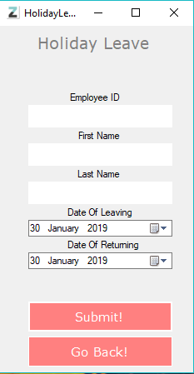
As you can see there is now a holiday leave application this allows employees to apply for holidays on dates they select. This can either be approved by an admin or disapproved and hopefully this feature should be fully functioning soon.
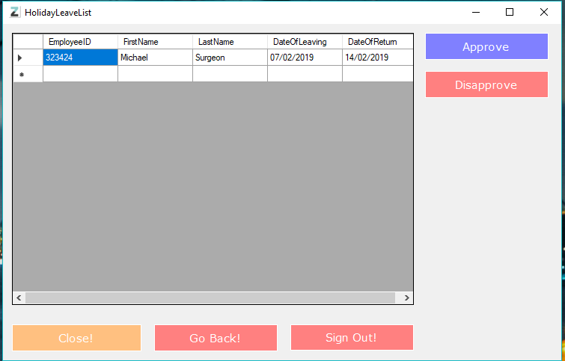
As you can see the admin can either approve the leaving day or disapprove depending on certain circumstances, hopefully I will have this fully functioning soon!
So the stage after this for me was adding a new registration system as I wasn’t so keen on the old one as there was no validation for things such as username and employeeIDs so therefor I took the time to do so as shown in the code below
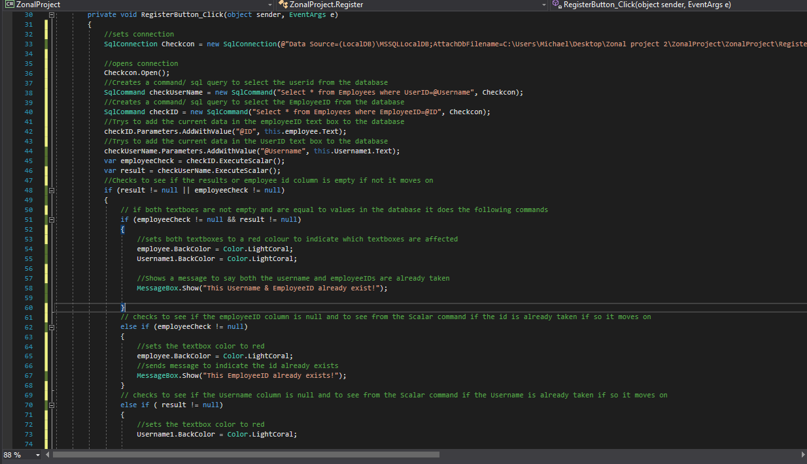
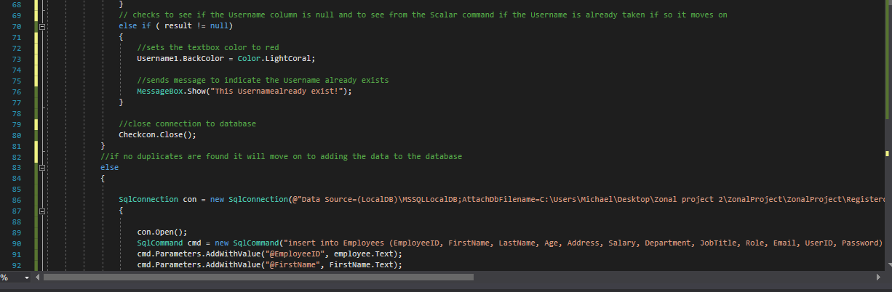
So this system was pretty straight forward and as you can see is well commented so you can see what it actually does and how it works it actually did take me a while to figure out how ExcuteScalar worked as I have never used it before but after I understood it, it made sense and I used it straight away I think this code is more organized and better than the last, and as you can see at the very bottom the new registration code uses parameters and values instead of adding values straight to the database this was just easier and more efficient and made the code easier to read as well I still need to work on salary as shown below as its still inefficient and doesn’t directly work if an admin was to add a role.
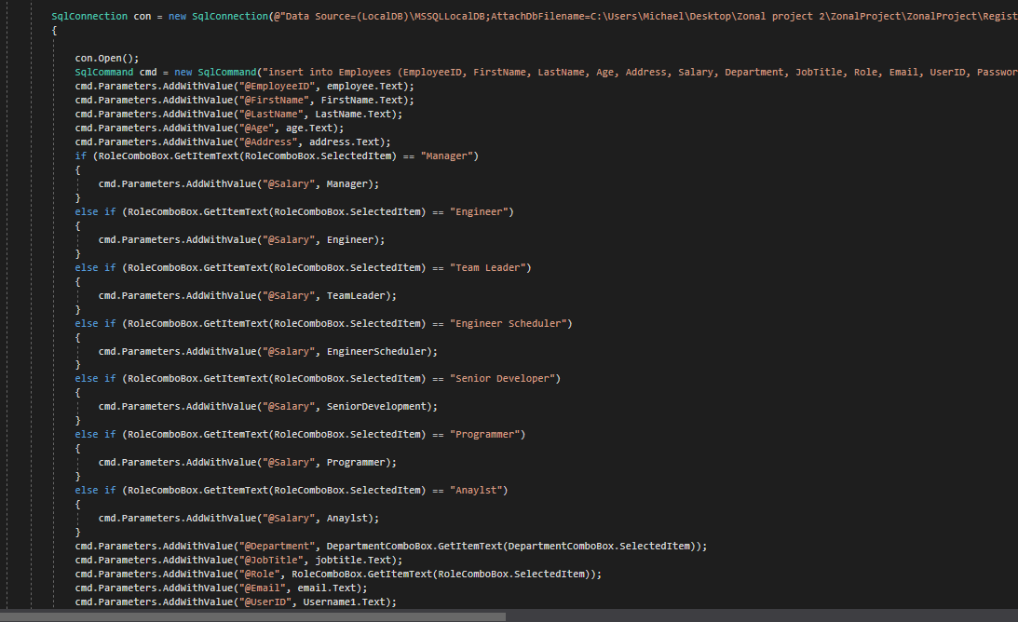
It is a lot better but doesn’t work with role adding.
So there is one bug with this system and that is I forgot to add validation for if any fields of the textboxes this was a simple fix as shown below
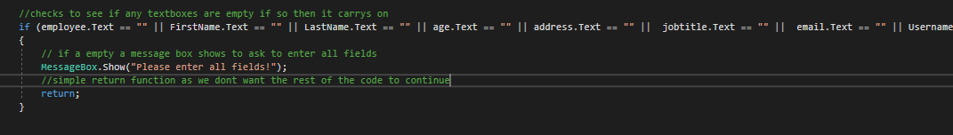
As you can see this was an easy fix basically just check all the textboxes if they are empty spit out a message reminding the user to enter all the data necessary then return to the start of the function so it doesn’t continue registering

So now onto the more complicated things now this took me a long time and I mean a long time, so its now time to mark of the list encryptions for passwords, this took way to long as I have never ever done it before but after some research I was able to find out how to do it and I learned how to understand it. So lets get started
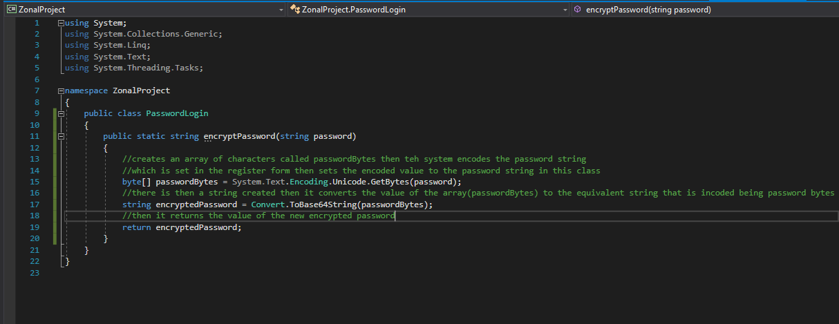
So what your looking at is a new class called PasswordLogin and basically the purpose of this class is too create a new array of characters and then we set that specific id to the password, I know this is hard to gather but keep with it. So the first line creates a new array of characters then sets that list of characters to a string that is called password that is passed through the main string. Then the new string created takes the value that has been converted or encoded you could say and stores it then returns that password.
This is shown in the database here :
As you can see the passwords are basically set to random chars this makes it a lot harder to hack etc the only thing I think security wise I have to work on is prevention from sql injection through textboxes on forms etc but I’m still learning how to do these things. Anyway, carrying on this is how the encryption works on logging in and registering an account.
So obviously the look very similar so the top one is on registration this basically takes the password and turns it into the char that is randomly create in the PasswordLogin class, the second line you may thin why am I adding it to the database for a second time well while logging in it isn’t adding it butt instead it is selecting the users password through this line of code :
The code is the same for the password as the username but this basically selected the user id and password and then the program verifies that the password matches and is infact in the database.
The next thing I done was making the login case sensitive as it wasn’t before and obviously this is important to security for obvious reasons. This is also another feature I had no idea how to do it but after learning how to do it, it was rather easy to implement actually so the line of code was this.string checkLogin = "select UserID,Password from Employees where UserID=@Username COLLATE Latin1_General_CS_AS and Password=@Password COLLATE Latin1_General_CS_AS ";

So basically, it’s the same as the old system the only thing that has changed is the COLLATE function within sql and the SQL_Latin1_General_CP1_CS_AS, So starting with the first
function this defines a collation of a database or table column, and for the other is basically just a collation for English(United Kingdom) locale which is a time zone or language etc. Where as SQL_Latin1_General_CP1_CS_AS is the default collation for English(United states) locale. The main part of this function is CS this basically means case sensitive and therefore we need it. And AS provides a bit more validation as it makes the password and username accent sensitive.

So more exciting stuff happened today so basically I have finally got a forgot password thing in place and also it has an automatic email system where it will send a verification code now this is another one of they systems that is hard to understand so bare with me!
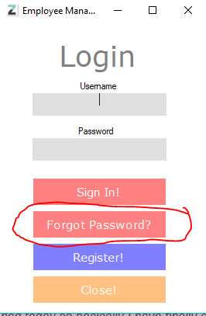
So as you can see this is the button on the login is screen its very simple so far.

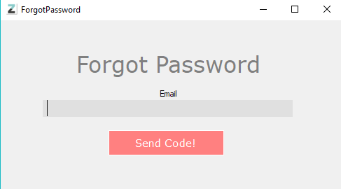
Then you are prompted with this page which allows you to type in your email and send a verification code to that email now I will be adding a go back button after this!
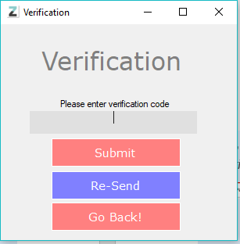
So after pressing send code it will then auto send an email to your email with a random number for verification and then you are prompt with a verification code panel.
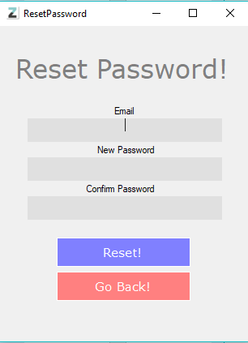
Once putting in the correct code you can then reset your password and I know what your thinking how can you validate it is that user in the database now this is where a nice we bit of programming has taken place so it will make sure the email you used to send the code to is the same as the entered email here and then it will match it to the database and reset your password if you type in the wrong email you will get this screen!
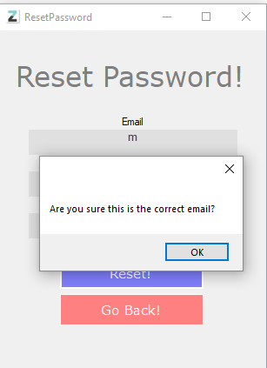
So as you can see it is secure and when resetting your password it re-encrypts it, It works perfectly.
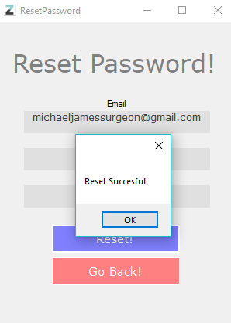
If the email is correct then you will reset with no issues now on to the code behind this.
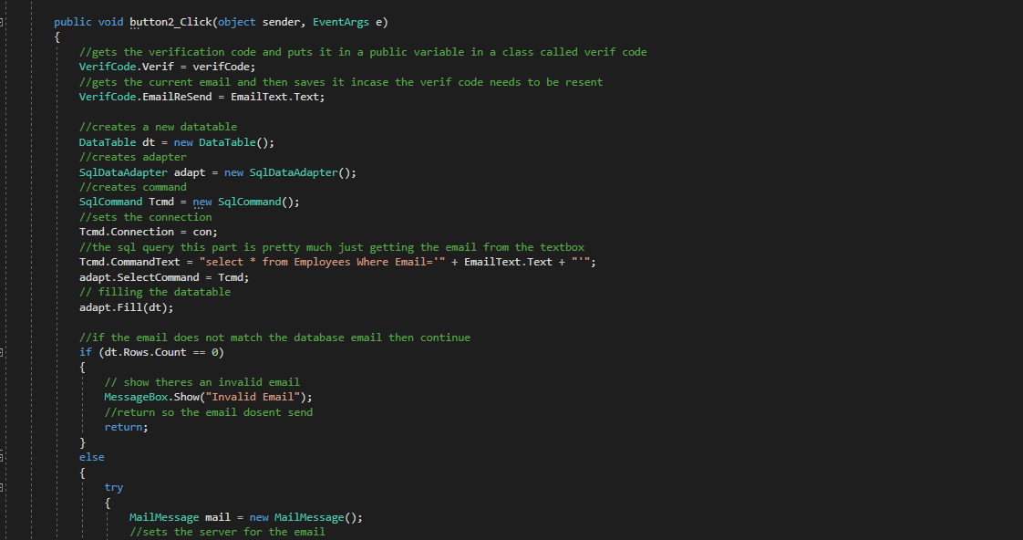
So this first part is quite self-explanatory so I create a new data table and fill it with the information of the table employees where the email is of the current user, we then check to see if the entered email is part of the database if not it will pop up a message saying its invalid then you will have the chance to retype, if the email is in the system it carries out the following code :
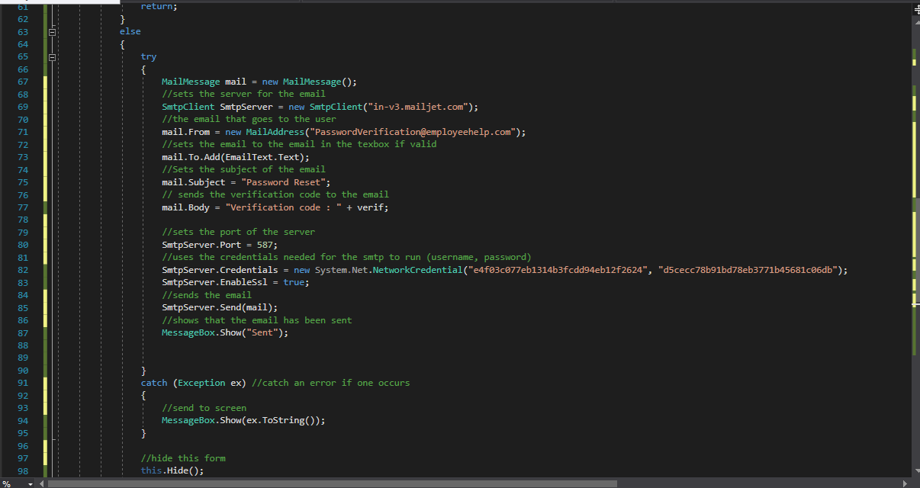
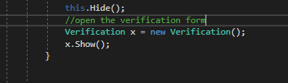

So this is the sort of complicated part it creates a new smpt client which is basically the server in which the email is sent across I then pick my email that was set up through a free domain service, I then set the subject of the email and the send the body which includes the random number that is the verification code the code for that is here :

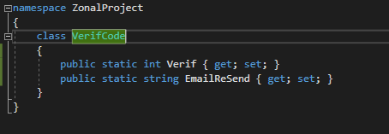
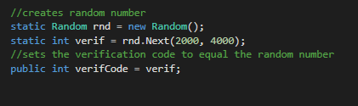
So this is basically how the verification code works it creates a new random which is predefined function, then sets the int verify equal to a random number between 2000 and 4000 this number can be changed if needed the it then sets the random number into a new variable called verifCode this just makes it easier to put into the class which happens here :
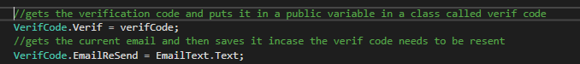
So, as you can see it stores the verification code but also the email so it can be resent if a problem occurs like the email doesn’t come through etc.
So, the next piece to the puzzle is updating the password in the database, now this proved to be more difficult than I first thought, but after a bit of planning I managed to do it.
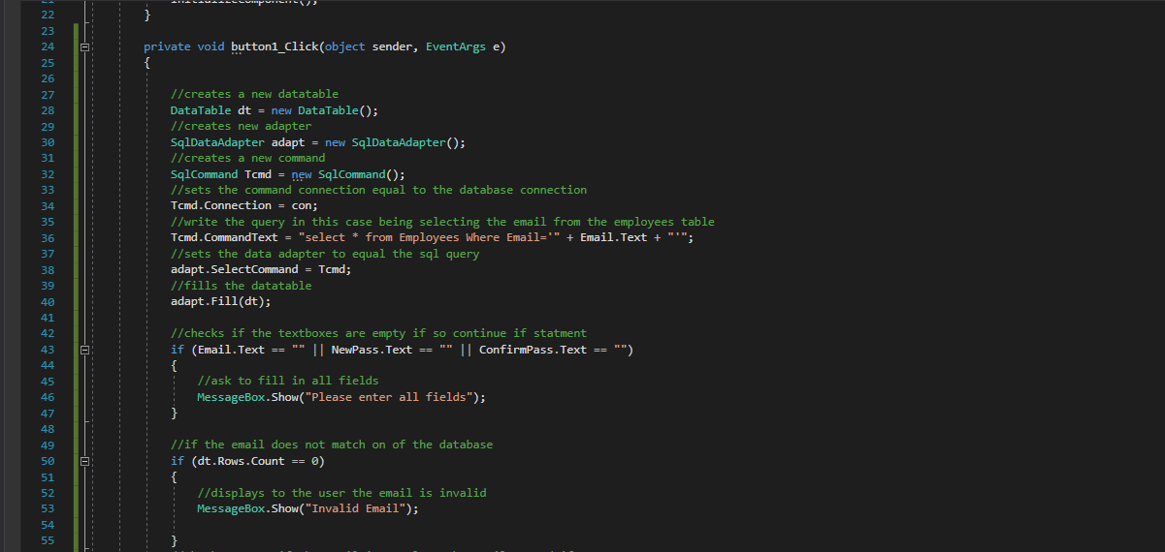
So, this first creates a new data table and then a new adapter the then sets the connection equal to the connection. Then we set the query in this case looking for the current used email. Then we fill the data table with that data from the query.
We then check to see if any fields are empty if so then we show an error message and the we check to see if the stated email is in the database if not then we show its invalid.
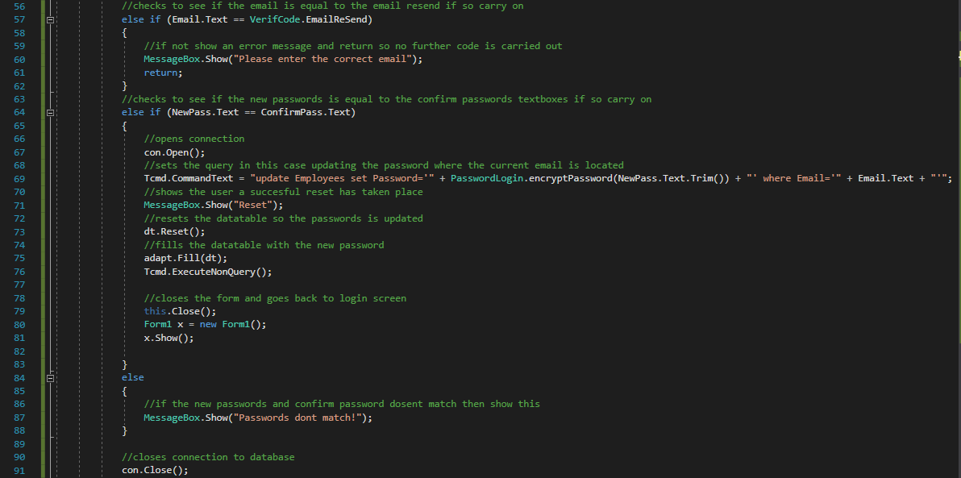
We then check to see if the typed In email is equal to the saved email in the class from before if so the continue if not we show and error message then return so the email doesn’t send, then we check to see if the new password is equal to the confirmed password of not we say “Passwords don’t match!” if they do match then we open the connection to the database then we create a new sql query/command which updates the employees table with the new password which is of course encrypted, we then show a message that states the reset was successful, I then reset the data table data so the password is fully updated then I fill the data table with new data, I then execute the non- query then I close the form and open the login form.
Now this code has one more optimization thing that I want to do and that is wrapping everything in the email validation to make sure no errors do occur with false emails etc.
I have also added a new registration validation so when an employee enters a username or employee id or both that are taken you will be given a warning and the text box will turn red depending on the already take ids or names.
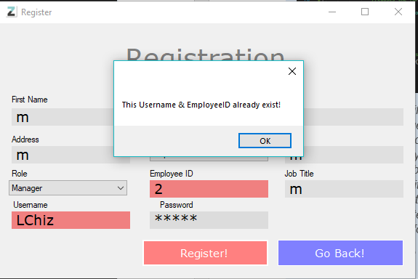
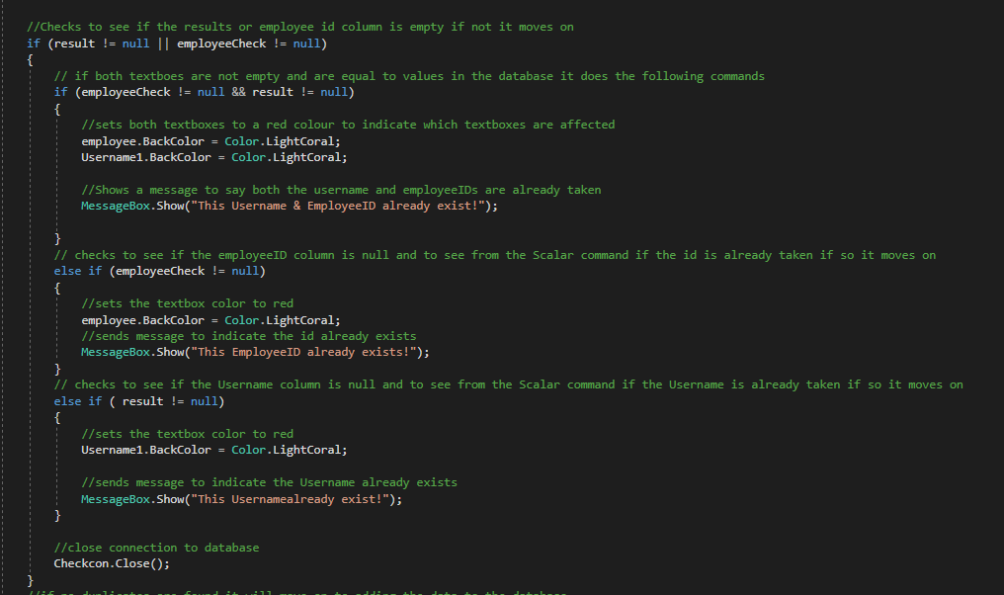
I have shown this code before but I never showed you the outcome on the form so this is where ill explain it, so the code works by checking the employee id and the username by these lines of code :
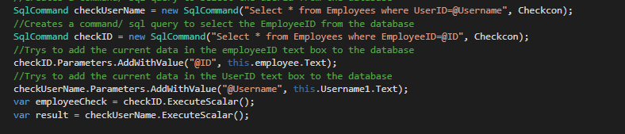
This basically creates a new command sets the query’s to select the employee id and userID and then ExcuteScalar them to check if they already exist, the in the next few lines we check to see if either are null and if that’s true it means they are already taken so we just send an error message out and set the textbox color. Pretty straight forward.
There is now another thing I can check of the list of things to do that being random assigning employeeIDs this was a lot easier than first thought this is how it works.
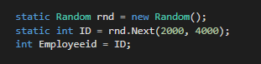
So firstly we use a pre-defined function called random this creates a random employee id for the user we then create a new int called employee id which is set to the random number.
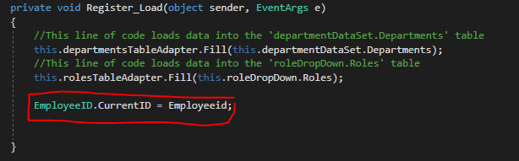
Then on the form load I set the new class variable called current id equal to the random number as shown below :
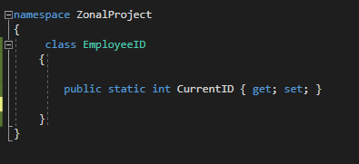
Then we write the random id to a log file located in the project folder

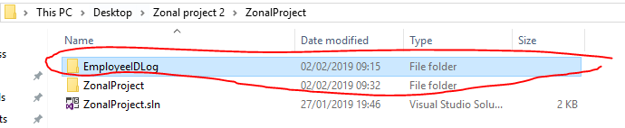
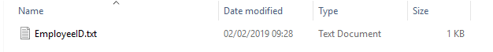
The way we write this is by using stream readers and writers as shown :
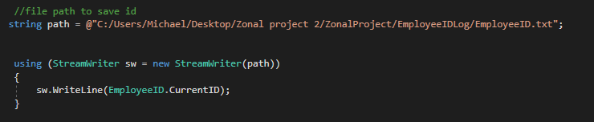
So when a user registers they trigger this which sends the id into the document that is written. And the reason we store it in a text file is because its an easy way to keep the value when the program closes.
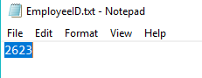
Then we have to read the file back into the same class variable we do this by using these lines of code :
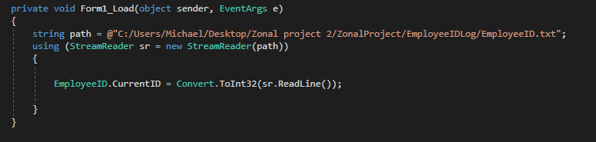
So as soon as the program launches the value is back where it was, so now I had to make sure the number couldn’t land on the same number twice the way I did this was by using this code :
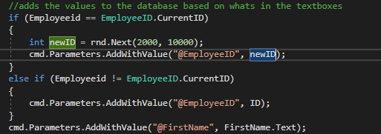
So the way this works is first the program checks if the newly generated employee id is the same as previous ones but this still needs some work as it only accounts for 1 at a time when it needs to account for the whole database of ids.
Well after some consideration there was a much easier way to do this and for the log it is a bit of a security risk so the new fix completely gets rid of the log and does all the employeeID random function through this.
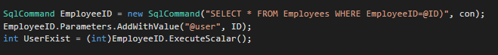
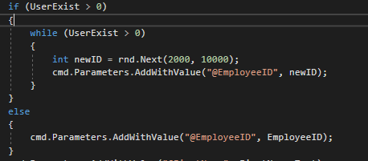
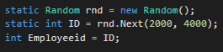
So This is a lot easier and works so much better as it checks the whole database for all employee id if the user name exits it pretty much creates a new random number and assigns it. And if the id is the same number again it will keep creating a new id until it’s a new ID.
There was an error in the sql and I had to fix this it was an easy fix as shown :
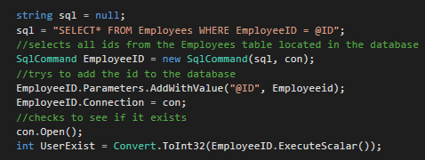
So, what happened was the ExcuteScalar command was trying to execute but since the value would turn out a null error I had to set the query to null then create the command.
Things to achieve from now on:
- Approve and disapprove holiday system
- Welcome message
- Update function
- Salary re-done

Well I defiantly messed up some where as I was getting errors with the database apparently already existing as I was sorting out the datasets and organizing my forms as shown :
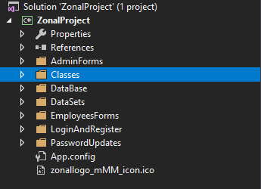
As you can see its a lot neater but this created a bunch off errors that I had to overcome the main one being the connection string so I had to come up with a new method of creating a data string that is not using the same string as the previous instance so after some research I found this.
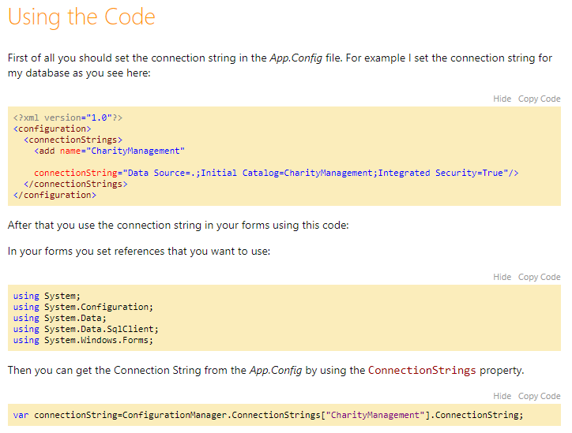
Now this greatly helped me overcome my issues by changing the xml string to be your data string the setting then setting that data string equal to the new connection string worked like a dream and made thing more efficient with the sql.
As you can see we can just search for EmployeeManagment which is = to the connection string so its easier to call in code through the using system.configuration namespace the way I called this was by using his method and adapting it :
So I basically just created a new connection and set the connection string to equal the connection this works really well.

NEW UI
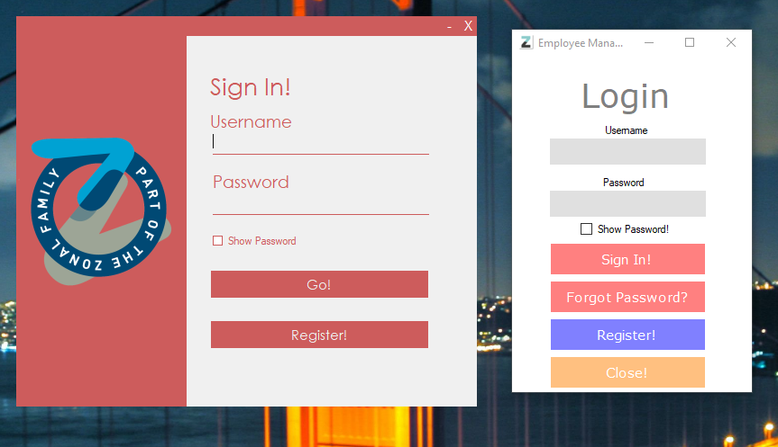
Login
Now that I have most of the code sorted and getting there its now time to create nicer layout for all the forms starting with the login! As you can see its very professional and good looking.
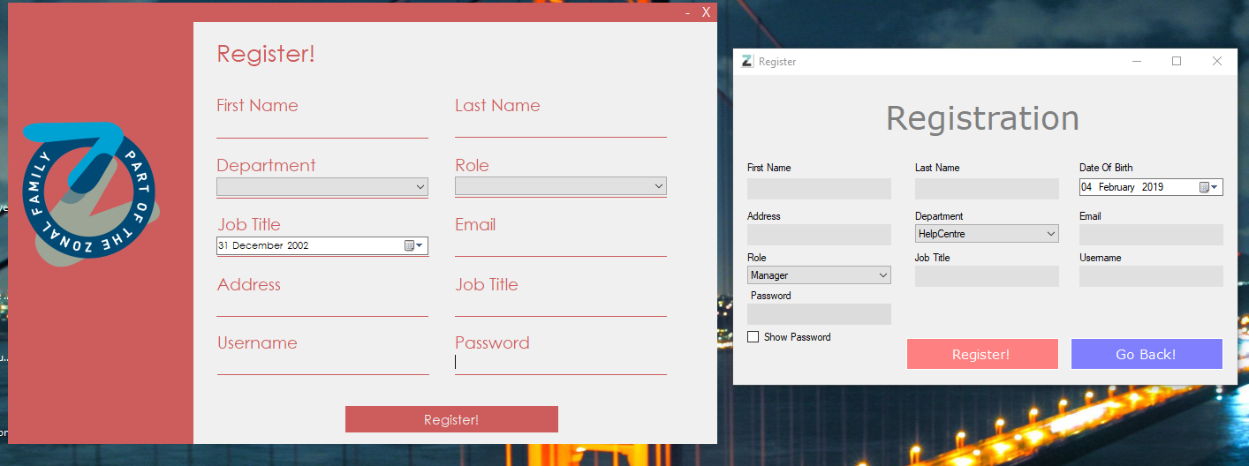
Register
This is the new register page it looks a lot cleaner. And yes I changed the job title duplication.
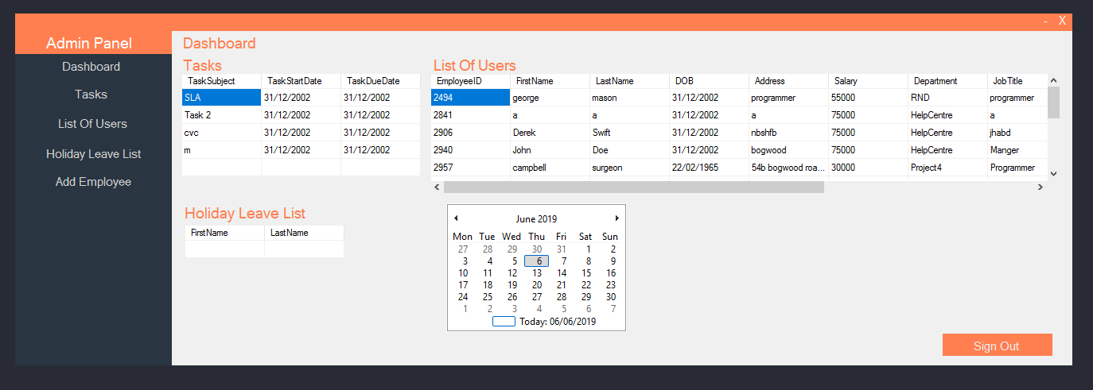
Admin Panel
Note: I have been using a new pc therefor I don’t have access to the older program to compare and the red has changed to an orange.

This is the new admin dashboard as you can see all the forms have been removed and turned into panels which has made the design look way more professional that before and makes the program look complete.
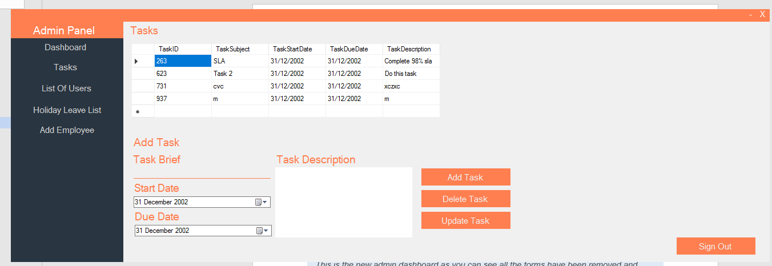
Tasks
This is the new tasks page and from my own personal opinion I think it looks sleek, smart but most importantly like a company program coming from a big client there could possibly be better use of space but that will be looked into.
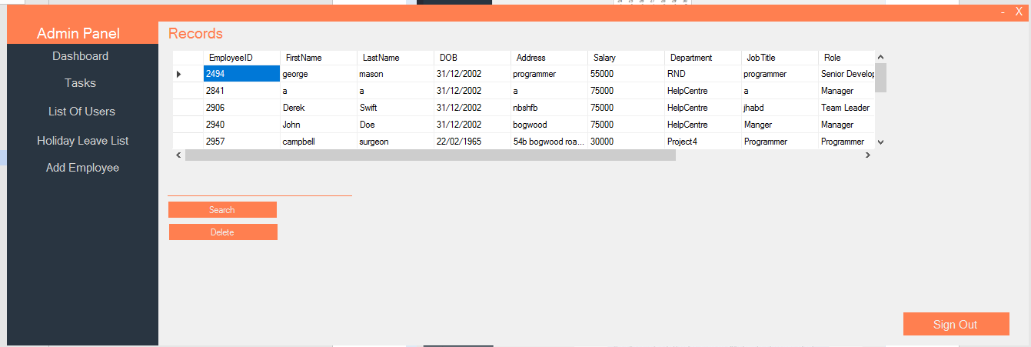
List of Users
This is the new records page compared to the old if I remember correctly it was clunky and old looking compared to this new design.
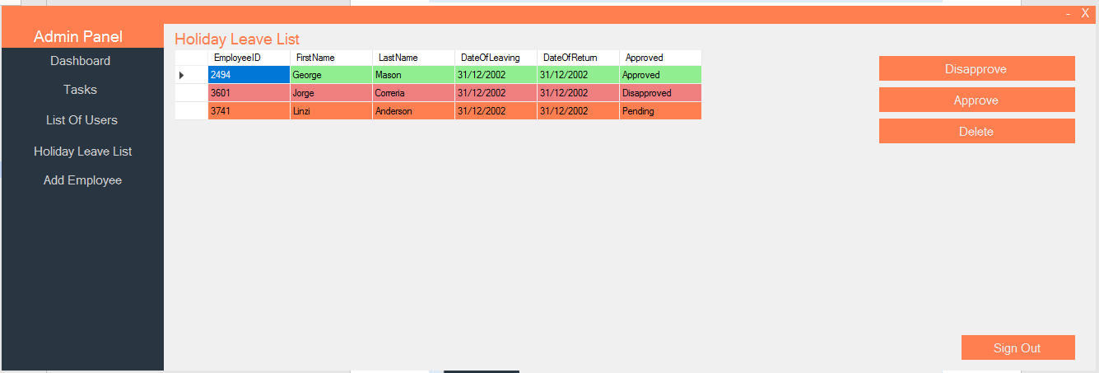
Holiday Leave List
This could possibly be my favorite page as the feature took so long to do but it was worth it as its now easy to Identify if an employee has been approved or disapproved for holiday this was worth the work.

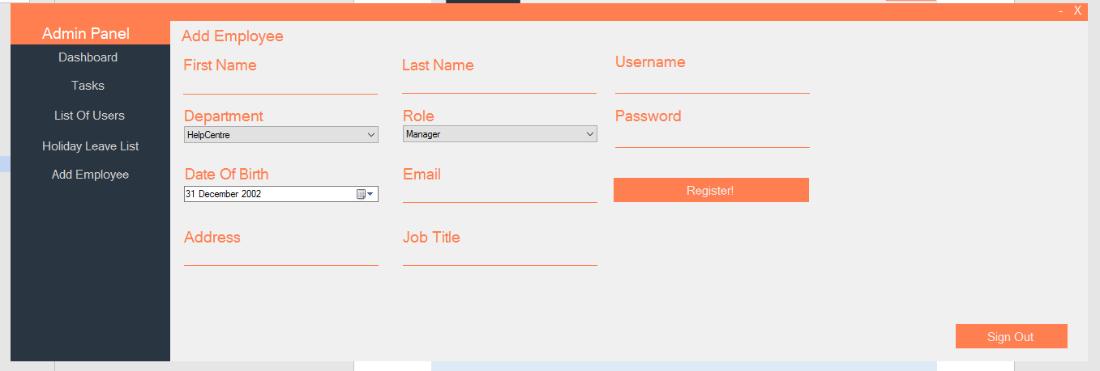
Add Employee
And Finally, for the admin panel we have our add employee panel its pretty and works well so this page went well.

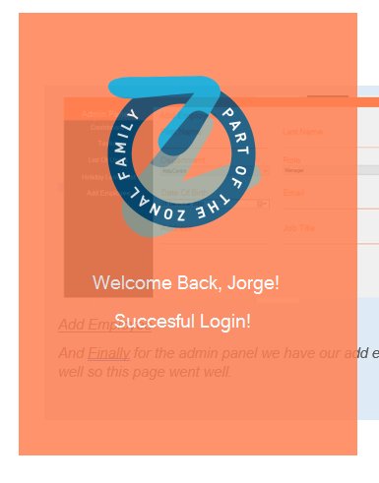
Welcome Page
So this was just a nice touch to add this is just a welcome message to the employee whenever they sign in it’s a nice little feature and adds a bit of individuality to the program.
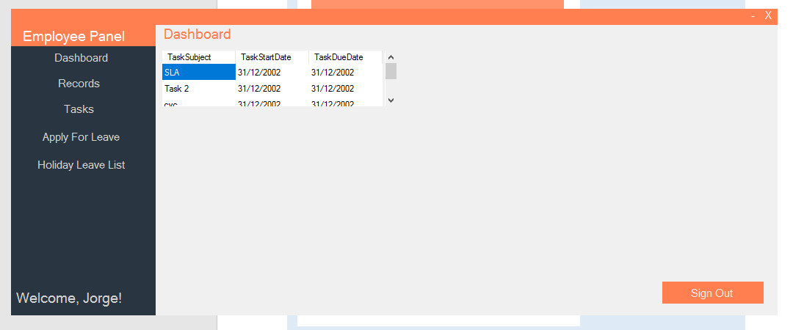
Employee Panel
So this is the new employee panel looking fresh there is still more to add the dashboard panel but im not certain onto what yet.
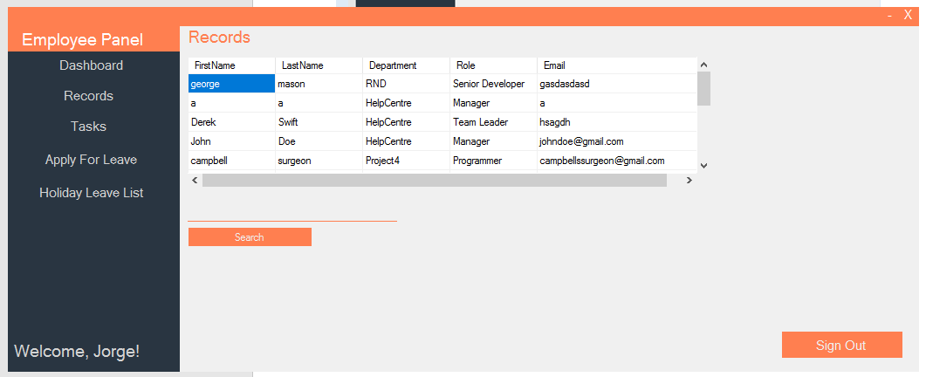
Employee Records
Just sticking to the theme for this panel and it works as expected.
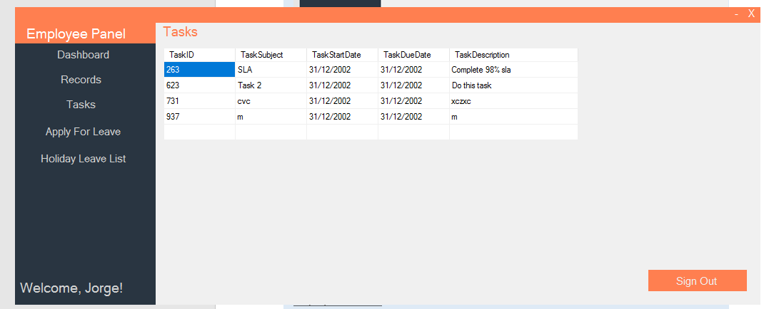
Tasks
Just a slimmed down version of the admin version looks nice and shows all relevant information.
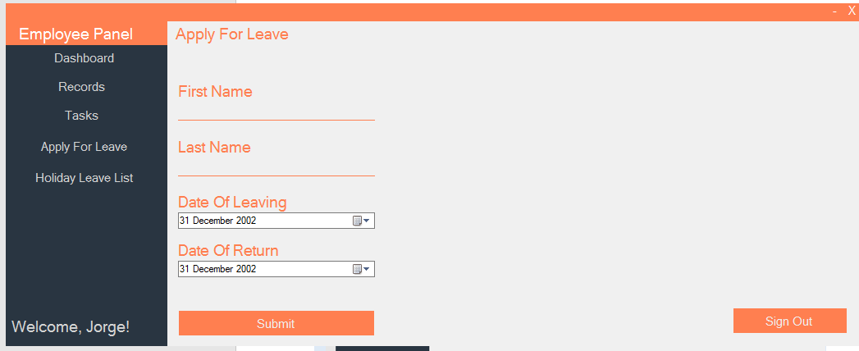
Holiday Leave Application
This panel looks a lot better than the last form and I think works very well because of the validation etc.
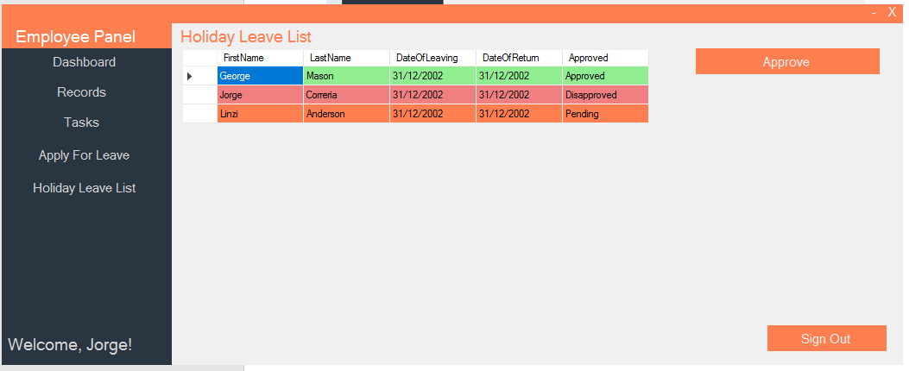
Holiday Leave List
Still one of my favorite panels in the whole program as its been the most rewarding I think it looks really good!

Conclusion for UI
In conclusion I think the new UI looks fantastic! As it helps the program look more professional and allows me to see the end scope of the program and it is really starting to get near the end so adding this just helps me improve the complete program overall and I’m really happy with how it turned out.

